Object Oriented Programming

Project Proposal



Submitted by:

**Hamza Safdar(SP21-BCS-025)**

**Khunsha Ahmed Khan(SP21-BCS-035)**

**Date:**

**30th June,2022**

Bike Showroom Management System

Introduction:

This is basic java GUI based project. It will be used to contain and keep complete record of bikes. This project will keep the records of bike details, company, customer and the admin details, the aim of this project is to provide all the detailed functionality related to bikes. We will develop all type of create, read, update, and delete operations of the bike showroom management system. Swing, one of java’s library is being used to add GUI.

**Classes:**

The main functionality of the management system is to manage the bike and their owner’s data. The main classes that are used to control this system’s data are as bellows:

1. **Vehicle:**

import java.io.Serializable;

public class Address implements Serializable {

String homeNumber;

String street;

String city;

Address(){}

Address(String homeNumber, String street, String city) {

this.homeNumber = homeNumber;

this.street = street;

this.city = city;

}

public String getHomeNumber() {

return homeNumber;

}

public void setHomeNumber(String homeNumber) {

this.homeNumber = homeNumber;

}

public String getStreet() {

return street;

}

public void setStreet(String street) {

this.street = street;

}

public String getCity() {

return city;

}

public void setCity(String city) {

this.city = city;

}

@Override

public String toString() {

return "Address{" +

"homeNumber='" + homeNumber + '\'' +

", street='" + street + '\'' +

", city='" + city + '\'' +

'}';

}

}

1. **Bike:**

import java.io.Serializable;

import java.io.*;

import java.util.*;

public class Bike extends Vehicle implements Serializable {

String type;

public Bike (){

super();

}

public Bike(String bikeNumberPlate,double bikeCC,String bikeColour,double price, String types) {

super(bikeNumberPlate,bikeCC,bikeColour,price);

this.type = types;

}

public String getTypes() {

return type;

}

public void setTypes(String types) {

this.type = types;

}

@Override

public String toString() {

return vehicleNumberPlate + "\t "+vehicleCC +"\t "+type +"\t"+ vehicleColour +"\t "+ price ;

}

public static void AddBike(Bike bO) {

try{

File file = new File("bikes.ser");

ObjectOutputStream oos;

if(file.exists()){

oos = new MyObjectOutputStream(new FileOutputStream(file,true));

}

else{

oos = new ObjectOutputStream(new FileOutputStream(file));

}

oos.writeObject(bO);

oos.close();

}

catch(IOException e){

System.out.println("Error in File Writing");

}

}

public static boolean RemoveBike(String numberPlate) {

boolean check = false;

ArrayList<Bike> bikes = new ArrayList<Bike>();

try {

ObjectInputStream ois = new ObjectInputStream(new FileInputStream("bikes.ser"));

while (true) {

Bike b = (Bike) ois.readObject();

bikes.add(b);

}

}

catch (ClassNotFoundException e) {

}

catch (EOFException e) {

}

catch (IOException e) {

}

catch (Exception e) {

}

for (int i = 0; i < bikes.size(); i++) {

if (bikes.get(i).getVehicleNumberPlate().equalsIgnoreCase(numberPlate)) {

bikes.remove(i);

check = true;

}

else if(i== bikes.size()-1&!(bikes.get(i).getVehicleNumberPlate().equalsIgnoreCase(numberPlate))){

check = false;

}

}

try {

File f = new File("bikes.ser");

ObjectOutputStream ous = new ObjectOutputStream(new FileOutputStream(f));

ous.writeObject(bikes.get(0));

ous.close();

for (int i = 1; i < bikes.size(); i++) {

ous = new MyObjectOutputStream(new FileOutputStream(f,

true));

ous.writeObject(bikes.get(i));

}

ous.close();

} catch (IOException e) {

System.out.println("IO Exception");

} catch (Exception e) {

System.out.println(e.getMessage());

}

return check;

}

public static Bike checkStock(String numberPlate) {

ObjectInputStream ois = null;

try {

ois = new ObjectInputStream(new FileInputStream("bikes.ser"));

while (true) {

Bike b = (Bike) ois.readObject();

if(b.getVehicleNumberPlate().equalsIgnoreCase(numberPlate)){

return b;

}

}

}

catch(ClassNotFoundException e){

return null;

}

catch(EOFException e){

System.out.println("Bike not found.");

return null;

}

catch(IOException e){

return null;

}

finally {

try{

ois.close();

}

catch (Exception e){

System.out.println(e.getMessage());

}

}

}

public static Bike searchByType(String numberPlate) {

ObjectInputStream ois = null;

try {

ois = new ObjectInputStream(new FileInputStream("soldBikes.ser"));

while (true) {

Bike b = (Bike) ois.readObject();

if(b.getTypes().equalsIgnoreCase(numberPlate)){

return b;

}

}

}

catch(ClassNotFoundException e){

return null;

}

catch(EOFException e){

System.out.println("Bike not found.");

return null;

}

catch(IOException e){

return null;

}

finally {

try{

ois.close();

}

catch (Exception e){

System.out.println(e.getMessage());

}

}

}

public static void updatePriceOfBike (String key,Double update){

ArrayList<Bike> bikesList = new ArrayList<Bike>();

try{

ObjectInputStream ois = new ObjectInputStream(new

FileInputStream("bikes.ser"));

while(true){

Bike b = (Bike)ois.readObject();

bikesList.add(b);

}

}

catch (ClassNotFoundException e) {

}

catch(EOFException e){

}

catch (IOException e) {

}

catch(Exception e){

}

for(int i=0;i<bikesList.size();i++){

if(bikesList.get(i).getVehicleNumberPlate().equalsIgnoreCase(key)){

bikesList.get(i).setPrice(update);

}

}

try{

File f = new File("bikes.ser");

ObjectOutputStream ous = new ObjectOutputStream(new

FileOutputStream(f));

ous.writeObject(bikesList.get(0));

ous.close();

for(int i=1;i<bikesList.size();i++){

ous = new MyObjectOutputStream(new FileOutputStream(f,

true));

ous.writeObject(bikesList.get(i));

}

ous.close();

}

catch (IOException e) {

System.out.println("IO Exception");

}

catch(Exception e){

return;

}

}

public static void AddSoldBike(Bike bO) {

try{

File file = new File("soldBikes.ser");

ObjectOutputStream oos;

if(file.exists()){

oos = new MyObjectOutputStream(new FileOutputStream(file,true));

}

else{

oos = new ObjectOutputStream(new FileOutputStream(file));

}

oos.writeObject(bO);

oos.close();

}

catch(IOException e){

System.out.println("Error in File Writing");

}

}

public static Bike SearchInSold(String numberPlate) {

ObjectInputStream ois = null;

try {

ois = new ObjectInputStream(new FileInputStream("soldBikes.ser"));

while (true) {

Bike b = (Bike) ois.readObject();

if(b.getVehicleNumberPlate().equalsIgnoreCase(numberPlate)){

return b;

}

}

}

catch(ClassNotFoundException e){

return null;

}

catch(EOFException e){

System.out.println("Bike not found.");

return null;

}

catch(IOException e){

return null;

}

finally {

try{

ois.close();

}

catch (Exception e){

System.out.println(e.getMessage());

}

}

}

public static Bike SearchGreaterThanAmount(double amount) {

ObjectInputStream ois = null;

try {

ois = new ObjectInputStream(new FileInputStream("bikes.ser"));

while (true) {

Bike b = (Bike) ois.readObject();

if(b.getPrice()>50000){

return b;

}

}

}

catch(ClassNotFoundException e){

return null;

}

catch(EOFException e){

System.out.println("Bike not found.");

return null;

}

catch(IOException e){

return null;

}

finally {

try{

ois.close();

}

catch (Exception e){

System.out.println(e.getMessage());

}

}

}

}

**3.Address**

import java.io.Serializable;  
  
public class Address implements Serializable {  
 String homeNumber;  
 String street;  
 String city;  
  
 Address(){}  
  
 Address(String homeNumber, String street, String city) {  
 this.homeNumber = homeNumber;  
 this.street = street;  
 this.city = city;  
 }  
  
 public String getHomeNumber() {  
 return homeNumber;  
 }  
  
 public void setHomeNumber(String homeNumber) {  
 this.homeNumber = homeNumber;  
 }  
  
 public String getStreet() {  
 return street;  
 }  
  
 public void setStreet(String street) {  
 this.street = street;  
 }  
  
 public String getCity() {  
 return city;  
 }  
  
 public void setCity(String city) {  
 this.city = city;  
 }  
  
 @Override  
 public String toString() {  
 return "Address{" +  
 "homeNumber='" + homeNumber + '\'' +  
 ", street='" + street + '\'' +  
 ", city='" + city + '\'' +  
 '}';  
 }  
}

**4.Date:**

import java.io.Serializable;  
  
public class Date implements Serializable {  
 int day;  
 int month;  
 int year;  
  
 public Date() {  
 }  
  
  
 public Date(int day, int month, int year) {  
 this.day = day;  
 this.month = month;  
 this.year = year;  
 }  
  
 public void setDay(int day) {  
 this.day = day;  
 }  
  
 public int getMonth() {  
 return month;  
 }  
  
 public void setMonth(int month) {  
 this.month = month;  
 }  
  
 public int getYear() {  
 return year;  
 }  
  
 public void setYear(int year) {  
 this.year = year;  
 }  
  
 @Override  
 public String toString() {  
 return day +"/"+ month +"/"+ year;  
 }  
}

**5**.**Person**:

import java.io.Serializable;  
  
public class Person implements Serializable {  
 String name;  
 int age;  
 Address address;  
 String CNIC;  
  
 Person (){  
 address = new Address();  
 }  
  
 public Person(String CNIC,String name, int age, Address address) {  
 this.name = name;  
 this.age = age;  
 this.address = address;  
 this.CNIC = CNIC;  
 }  
  
 public String getCNIC() {  
 return CNIC;  
 }  
  
 public void setCNIC(String CNIC) {  
 this.CNIC = CNIC;  
 }  
  
 public String getName() {  
 return name;  
 }  
  
 public void setName(String name) {  
 this.name = name;  
 }  
  
 public int getAge() {  
 return age;  
 }  
  
 public void setAge(int age) {  
 this.age = age;  
 }  
  
 public Address getAddress() {  
 return address;  
 }  
  
 public void setAddress(Address address) {  
 this.address = address;  
 }  
  
  
 @Override  
 public String toString() {  
 return "Person{" +  
 "name='" + name + '\'' +  
 ", age=" + age +  
 ", address=" + address +  
 ", CNIC=" + CNIC +  
 '}';  
   
 }  
  
 public static boolean isCNICValid(String cnic) {  
 boolean check = true;  
 if (cnic.length() == 13) {  
 for (int i = 0; i < cnic.length(); i++) {  
 if (!Character.*isDigit*(cnic.charAt(i))) {  
 check = false;  
 break;  
 }  
 }  
 }  
 else {  
 check = false;  
 }  
 return check;  
 }  
  
  
  
 public static boolean isAgeValid(int age){  
 boolean check = true;  
 if (age > 18) {  
 check = true;  
 }  
 else {  
 check = false;  
 }  
 return check;  
 }  
}

**6.Bike Owner:**

import java.io.*;  
import java.util.ArrayList;  
import jdk.swing.interop.SwingInterOpUtils;  
  
import javax.swing.*;  
  
  
public class BikeOwner extends Person implements Serializable {  
 Date dateOfBuying;  
 String purchasedVehicle;  
  
  
 public BikeOwner() {  
 dateOfBuying = new Date();  
 }  
  
 public BikeOwner(String CNIC,String name, int age, Address address, Date dateOfBuying,String purchasedVehicle) {  
 super(CNIC,name, age, address);  
 this.dateOfBuying = dateOfBuying;  
 this.purchasedVehicle = purchasedVehicle;  
 }  
  
 public Date getDateOfBuying() {  
 return dateOfBuying;  
 }  
  
 public void setDateOfBuying(Date dateOfBuying) {  
 this.dateOfBuying = dateOfBuying;  
 }  
  
 public String getPurchasedVehicle() {  
 return purchasedVehicle;  
 }  
  
 public void setPurchasedVehicle(String purchasedVehicle) {  
 this.purchasedVehicle = purchasedVehicle;  
 }  
  
 @Override  
 public String toString() {  
 return name + "\t "+CNIC +" "+purchasedVehicle +"\t"+ age +"\t "+ dateOfBuying.toString();  
// "BikeOwner{" +  
// "dateOfBuying=" + +  
// ", purchasedVehicle='" + + '\'' +  
// ", name='" + + '\'' +  
// ", age=" + +  
// ", address=" + address.toString() +  
// ", CNIC='" + + '\'' +  
// '}';  
 }  
  
 public static void AddBikeOwner(BikeOwner bO) {  
 try{  
 File file = new File("bikeOwners.ser");  
 ObjectOutputStream oos = null;  
 if(file.exists()){  
 oos = new MyObjectOutputStream(new FileOutputStream(file,true));  
 }  
 else{  
 oos = new ObjectOutputStream(new FileOutputStream(file));  
 }  
  
 System.out.println(bO.toString());  
 oos.writeObject(bO);  
 oos.close();  
 }  
// catch(EOFException e){  
// System.out.println("File ended");  
// }  
// catch(FileNotFoundException e){  
// System.out.println(e.getMessage());  
// }  
 catch (Exception e){  
 System.out.println(e.getMessage());  
 }  
}  
  
  
  
 public static boolean RemoveBikeOwner(String name) {  
 boolean check = false;  
 ArrayList<BikeOwner> bikeOwners = new ArrayList<BikeOwner>();  
 try {  
 ObjectInputStream ois = new ObjectInputStream(new FileInputStream("bikeOwners.ser"));  
 while (true) {  
 BikeOwner bO = (BikeOwner) ois.readObject();  
 bikeOwners.add(bO);  
 }  
 }  
 catch (ClassNotFoundException e) {  
 }  
 catch (EOFException e) {  
 }  
 catch (IOException e) {  
 }  
 catch (Exception e) {  
 }  
 for (int i = 0; i < bikeOwners.size(); i++) {  
 if (bikeOwners.get(i).getName().equalsIgnoreCase(name)) {  
 bikeOwners.remove(i);  
 check = true;  
 }  
 else if(i== bikeOwners.size()-1&!(bikeOwners.get(i).getName().equalsIgnoreCase(name))){  
 check = false;  
 }  
 }  
 try {  
 File f = new File("bikeOwners.ser");  
 ObjectOutputStream ous = new ObjectOutputStream(new  
 FileOutputStream(f));  
 ous.writeObject(bikeOwners.get(0));  
 ous.close();  
 for (int i = 1; i < bikeOwners.size(); i++) {  
 ous = new MyObjectOutputStream(new FileOutputStream(f,  
 true));  
 ous.writeObject(bikeOwners.get(i));  
 }  
 ous.close();  
 } catch (IOException e) {  
 System.out.println("IO Exception");  
 } catch (Exception e) {  
 System.out.println(e.getMessage());  
 }  
 return check;  
 }  
  
  
  
 public static BikeOwner SearchByName(String name) {  
 try {  
 ObjectInputStream ois = new ObjectInputStream(new  
 FileInputStream("bikeOwners.ser"));  
 while (true) {  
 BikeOwner bO = (BikeOwner) ois.readObject();  
 if(bO.getName().equalsIgnoreCase(name)){  
 return bO;  
 }  
 }  
 }  
 catch(ClassNotFoundException e){  
 return null;  
 }  
 catch(EOFException e){  
 System.out.println("Bike Owner not found.");  
 return null;  
 }  
 catch(IOException e){  
 return null;  
 }  
 }  
  
  
 public static BikeOwner SearchByCNIC(String carOwnerCNIC) {  
 try {  
 ObjectInputStream ois = new ObjectInputStream(new  
 FileInputStream("bikeOwners.ser"));  
 while (true) {  
 BikeOwner bO = (BikeOwner) ois.readObject();  
 if(bO.getName().equalsIgnoreCase(carOwnerCNIC)){  
 return bO;  
 }  
 }  
 }  
 catch(ClassNotFoundException e){  
 return null;  
 }  
 catch(EOFException e){  
 System.out.println("Bike Owner not found.");  
 return null;  
 }  
 catch(IOException e){  
 return null;  
 }  
 }  
  
  
 public static String display() {  
 String stu = "";  
 try {  
 ObjectInputStream ois = new ObjectInputStream(new  
 FileInputStream("bikeOwners.ser"));  
 while (true) {  
 BikeOwner s = (BikeOwner) ois.readObject();  
 stu += s.toString()+"\n";  
 }  
 }  
 catch(ClassNotFoundException e){  
 return "Class not found";  
 }  
 catch(EOFException e){  
 return stu;  
 }  
 catch(IOException e){  
 return "Error";  
 }  
 }  
}

**Frames:**

**Admin Frame:**

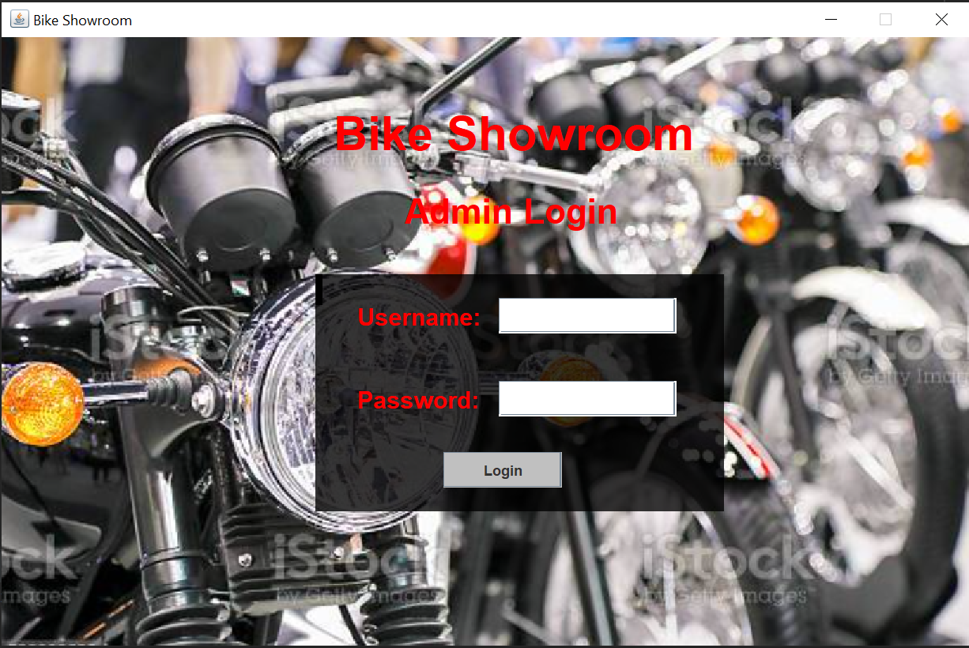

**Main Menu Frame:**

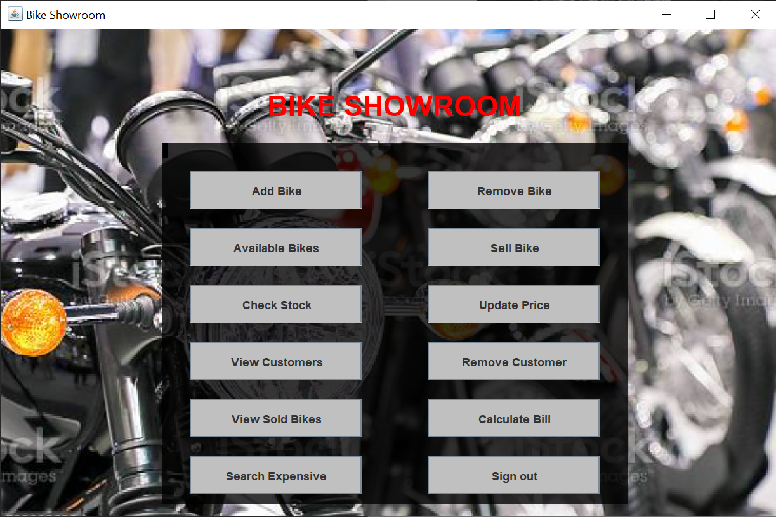

**Add Bike Frame:**

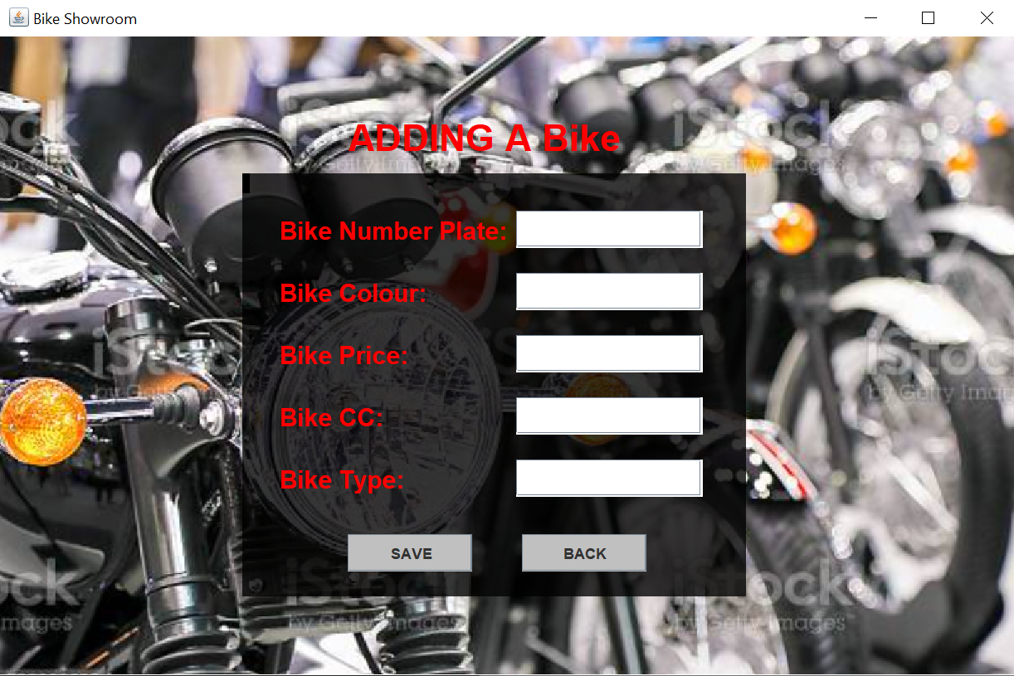

**Remove Bike Frame:**

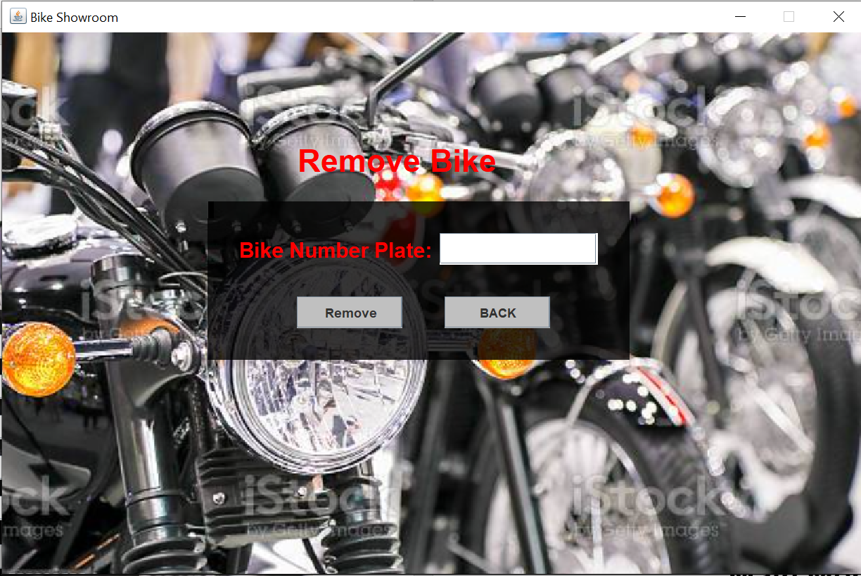

**Available Bikes Frame:**

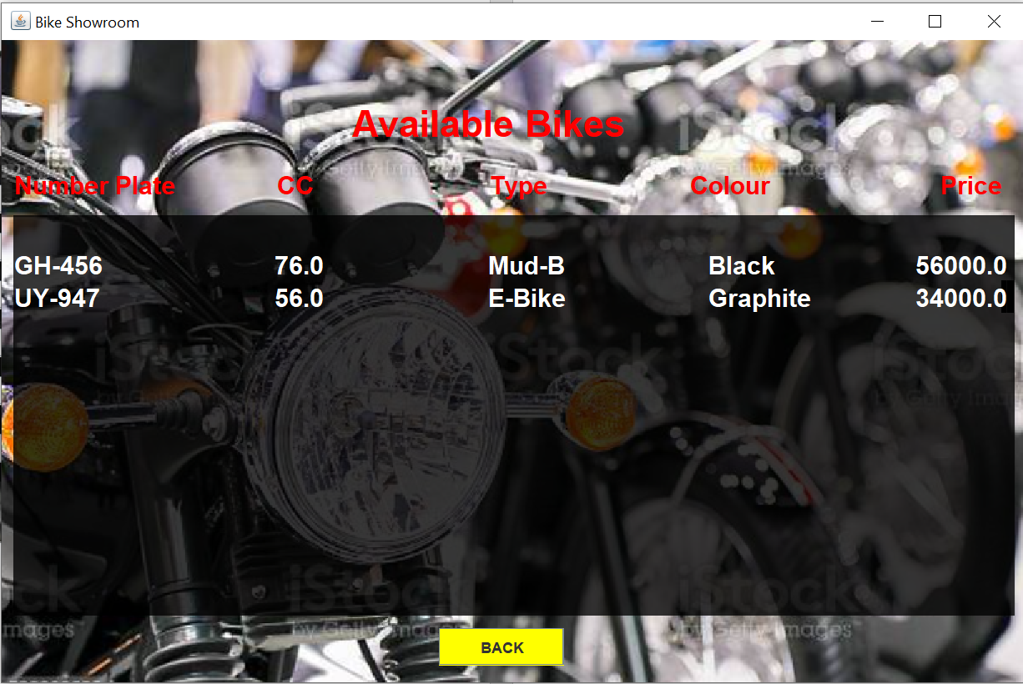

**Sell Bike Frame:**

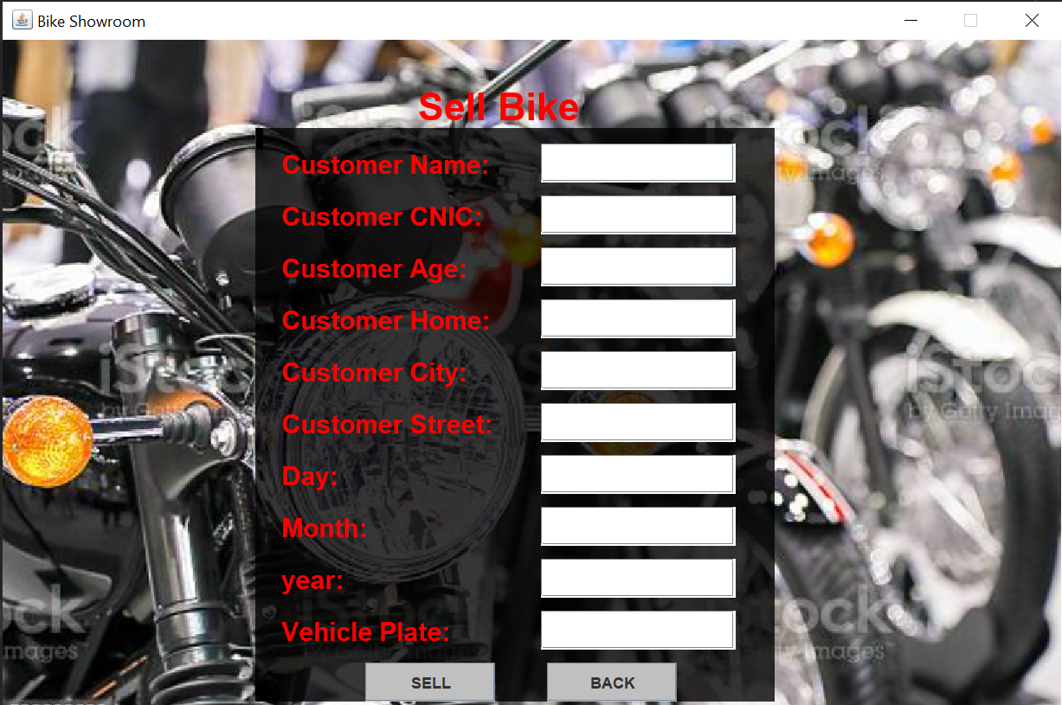

**Check Stock Frame:**

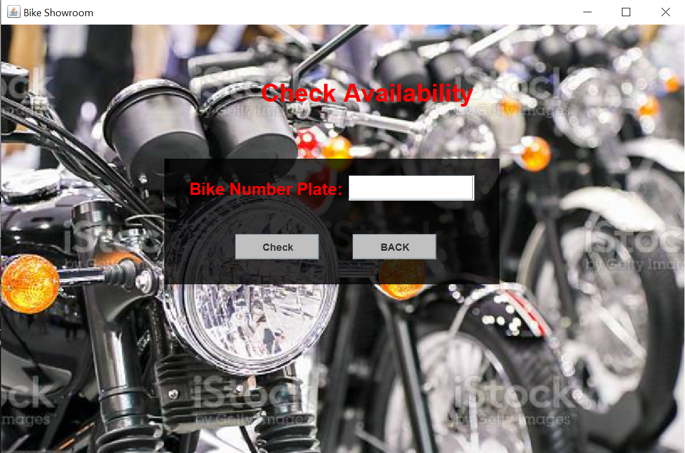

**Update Price Frame:**

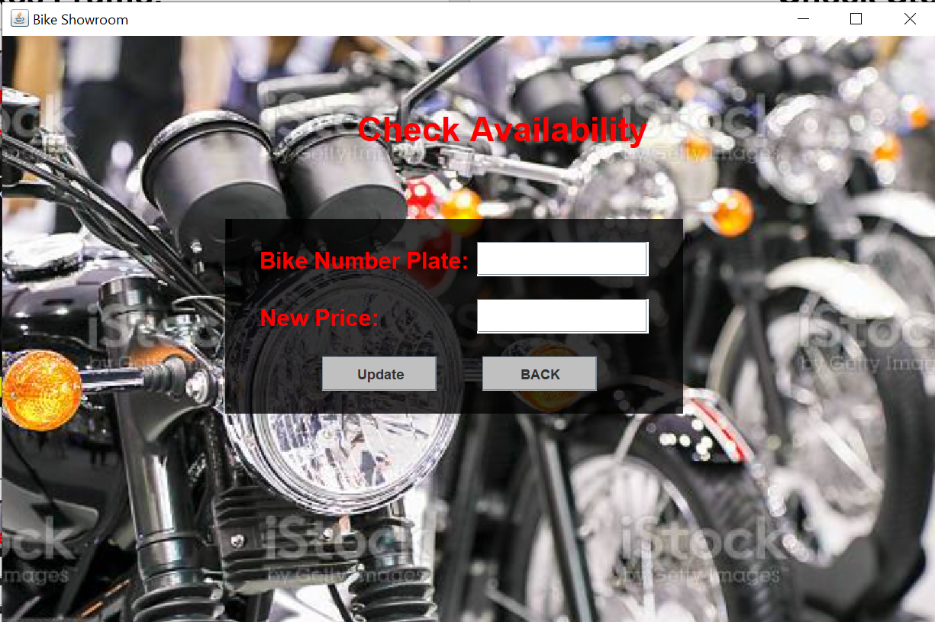

**View Customer Frame:**

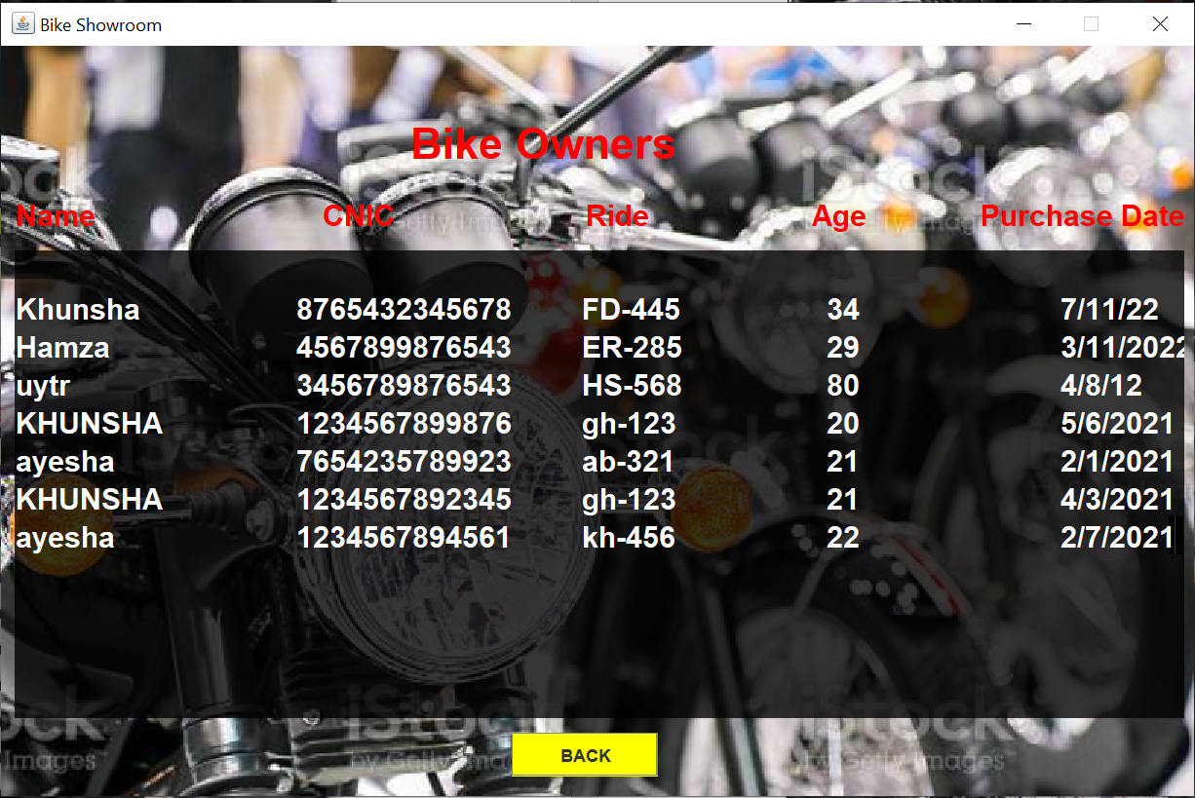 **Remove Customer Frame:**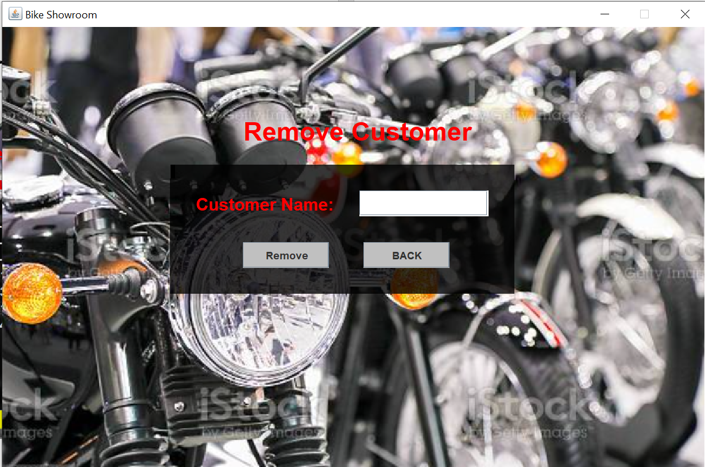

**View Sold Frame:**



**Calculate Bill Frame:**

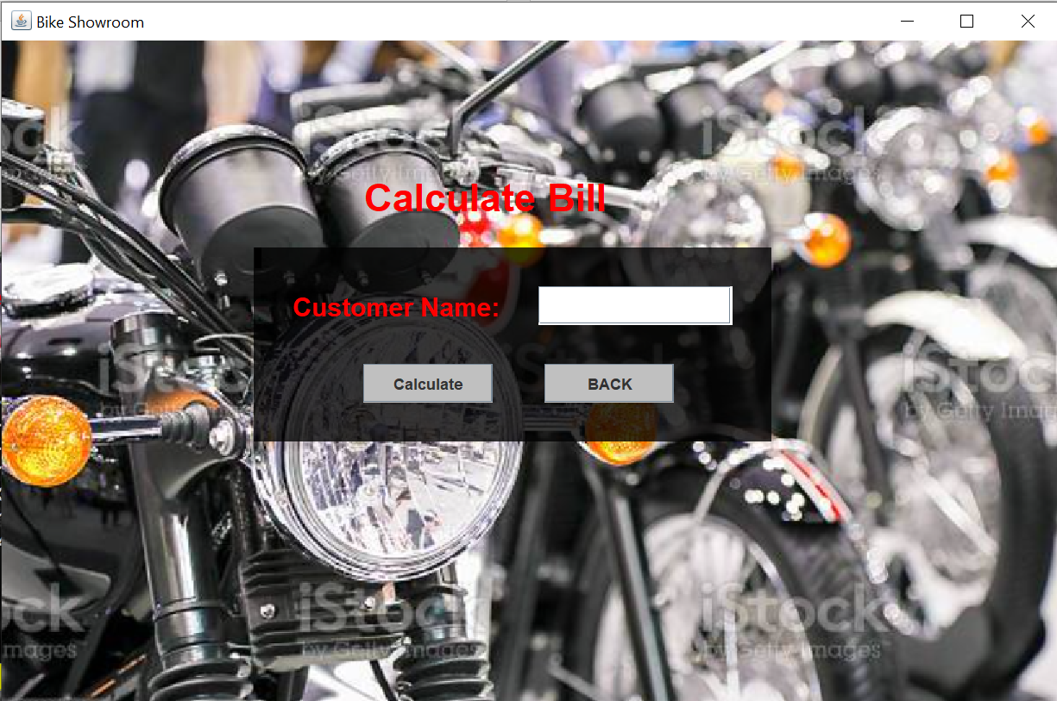

Attributes:

1. Making user experience convenient and hassle-free in bike showroom.
2. Password Protected admin login.
3. Use of basic GUI to give the user a pleasant experience.

Conclusion:

In this project we have made a bike management system with GUI and OOP concepts. This project enables us to polish our coding, GUI and OOP concepts. This helps us in understanding GUI and OOP concepts. Also, it remains effective as we work as a team and prepare such management system.